Guidance of Remote Access Based on Shibboleth

To access databases outside the campus based on Shibboleth, you do not need to download the client. Just log in with your CAS account to access the databases. You can access by the following steps:
1. On the webpage of “Off-Campus Access to E-resources”, find the database links for Shibboleth-based access.
2. Enter the login page for institution.
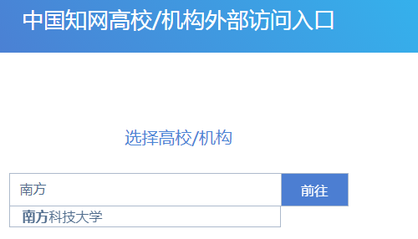
  - For some databases, users need to click “Sign in”or“Sign up”or“Login”to enter institution login page.
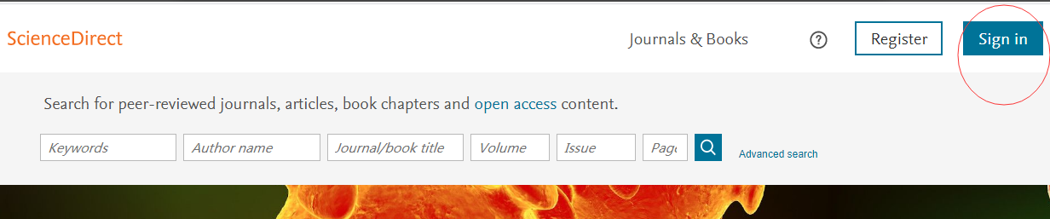

  - Choose“Sign in via your institution”or“Login via Shibboleth”or“通过机构登录”，Choose CHINA CERNET Federation to enter the next page.
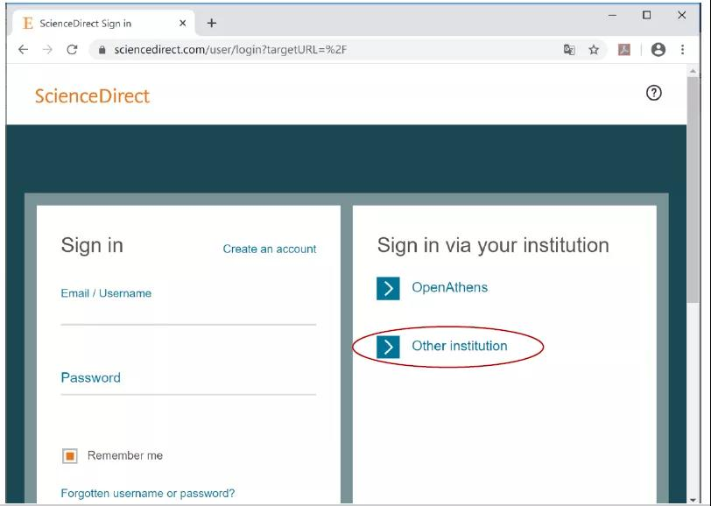
For other databases, you can skip“Step 1.2”
- Choose南方科技大学 or Southern University of Science and Technology
- Login with your CAS account and password
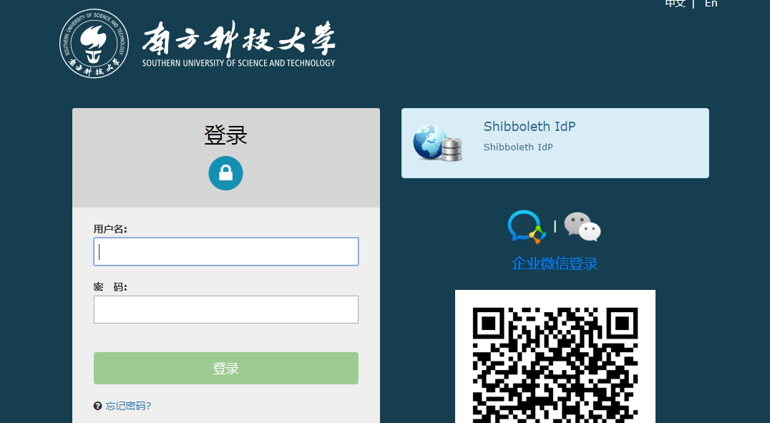
- You can access upon successful login. On the webpage normally you can see“Southern University of Science and Technology”
