New Oriental Interactive Oral English Platform
All you want to say is here to master spoken English with ease
1. Introduction to the Interactive Speaking Platform
New Oriental Interactive Speaking Platform is a student-centered intelligent interactive speaking learning product that brings together New Oriental's high-quality speaking teachers and teaching experts, in collaboration with domestic speech recognition technology partners. The platform covers a wide range of learning scenarios, combines teaching and practice, and is driven by intelligent technology to provide personalized, interactive and precise foreign language speaking solutions for students, helping learners improve their speaking skills efficiently.

2. Platform Sections
1. Basic Spoken Language:
New Oriental teacher's personal instruction, combined with specialized training in intelligent speech recognition, helps you easily master pronunciation, grammar, and basic expression.
2. Advanced Oral English:
New Oriental, in collaboration with Jianxi University, introduces breakthrough corpus-based teaching research results. The course content is scientific and practical, guiding you to master authentic and idiomatic English expressions.
3. Applied Oral English:
New Oriental Chinese and Foreign teachers work together to unlock real-life scenarios and fun topics! Teach authentic expressions beyond textbooks to help you apply what you've learned and communicate with confidence.
4 Cool Learning Oral English:
New Oriental teachers select popular British and American TV series, analyze trendy spoken language and classic expressions, expand high-frequency practical sentence patterns, allowing you to easily improve your spoken language while watching TV series.
5. Test-oriented oral English:
New Oriental teachers precisely analyze the key points of various oral tests, and through multi-dimensional learning reports and real-time feedback, help with efficient exam preparation and break through exam bottlenecks.
6. AI Practice Speaking:
Relying on New Oriental's own large model, we offer multi-language graded oral practice, one-on-one scene accompaniment, intelligent scoring and pronunciation correction to help you express yourself confidently.

3 Highlights of the platform
Multilingual graded practice: Supports multiple languages including English, French, Korean, Japanese, German, and you can choose CEFR A1-C1 difficulty levels
Scenario-based thematic dialogue: Covering over 30 daily and exam scenarios to meet the diverse learning needs of students
One-on-one interactive practice: Simulate real-life dialogues in restaurants, airports, etc. Start your oral practice at any time
Al Intelligent scoring and pronunciation correction: Real-time grammar correction and syllable-level scoring, one-click shadowing to strengthen weak points
Al Voice style selection: Multiple voice roles to choose from to stimulate students' interest in oral practice

4. Access methods
PC:
- PC web page: oral.koolearn.com
- On-campus access: Open the link and enter directly without logging in
- Off-campus access: Log in to your personal account (registration must be completed in advance on the off-campus PC)

Mobile:
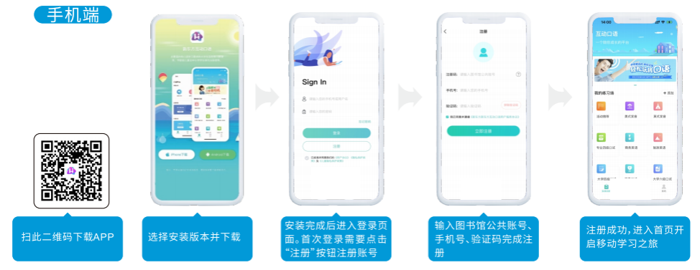
- Scan this QR code to download the APP
- Select the installation version and download
- Once the installation is complete, go to the login page. For the first login, you need to click the "Register" button to register an account
- Enter the library's public account, mobile phone number and verification code to complete the registration
- Register successfully and go to the home page to start your mobile learning journey
Southern University of Science and Technology Library Public Account: nfkjdxtskypt1
(Those who have already registered a personal account or a learning library account on a computer can log in directly with this account without the need for re-registration)

