Introduction to New Oriental's Mobile Learning Platform

- Introduction to the mobile Learning platform
The mobile learning platform is tailored by New Oriental Smart Education for various colleges and universities. Enable mobile learning anytime, anywhere and as you please, allowing you to study wherever you want, with the library at your fingertips.
1 Features of the Palm Learning product
- Excellence: A selection of exam-oriented, applied, basic, and advanced courses.
- Clever: A variety of course formats, including video, audio, text, and interactive practice courses, with lively and interesting content.
- Comprehensive: Listen, speak, read, write, translate. The course content is complete, application skills are covered in one net, thousands of courses are at your fingertips.
2 Master the curriculum system
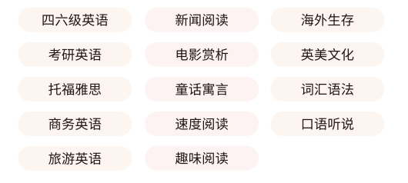
- Instructions for Use
- Scan and install



- Register and log in
After installation, go to the login page. For the first login, you need to register an account first. Click "Register" at the bottom of the page to enter the public account login page. Enter the library public account and password. Enter the personal account registration page. Follow the prompts to enter your personal mobile phone number and verification code to complete the login.
Registration code: Southern University of Science and Technology Registration code: nfkjdxtszsxxpt1 Password: 123
Note: New Oriental Multimedia Learning Library and Zhangxue accounts are interconnected. Those who have registered learning library accounts can log in and access directly with this account.

