New Oriental Micro-Classroom Learning Platform

1. Introduction to the Micro-classroom Learning Platform
New Oriental Micro Classroom Learning Platform (vl.koolearn.com) is a learning platform product developed by New Oriental Smart Education in response to the trend of micro learning and micro courses, with short videos as the core resource. It is positioned as a language application encyclopedia based on application scenarios.
The micro-classroom curriculum includes resources such as Smooth Learning of Spoken Language, Flexible Learning of Business, Enjoyable Learning of Foreign Languages, Language Examination, Study Abroad Express, Practice in the Workplace, Industry Strategies, etc.
Based on the boundaryless, customized design concept, micro-classroom not only supports computer learning, but also mobile apps and mobile WAP sites, achieving multi-screen integrated application, and also enables users to collect, download, and combine knowledge points for customized learning.
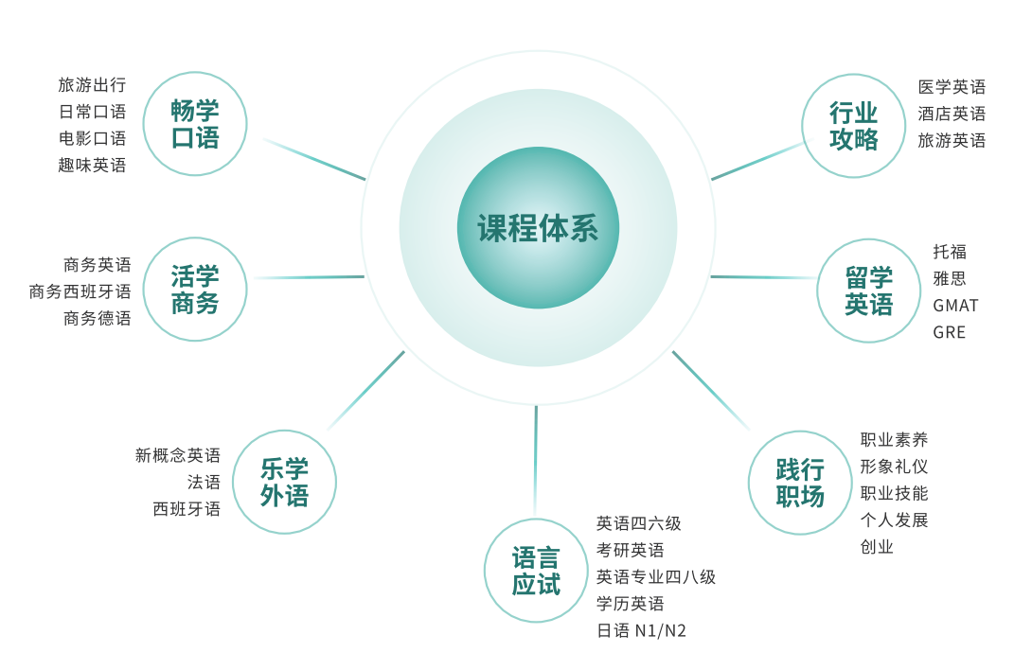

- Introduction to the features of micro-classes
1. Characteristics of Micro-classroom learning
(1) The first feature of micro-video learning is "micro", achieving "short learning" and "fast learning" through the miniaturization of materials;
(2) Satisfying students' autonomous needs, students choose their own learning content based on their own circumstances, with great flexibility;
(3) Enhanced learning efficiency, as students make their own choices, they have a strong desire to learn and are highly motivated, while effectively avoiding repetitive learning.
2 Characteristics of micro-classroom content
(1) "Short" : Each video in the Digital Image micro-classroom is an independent knowledge point and does not exceed 10 minutes;
(2) "small" : Independent knowledge points, more targeted learning, and smoother learning at the same time;
(3) "Fine" : Select outstanding teachers with rich teaching and research experience in New Oriental's online education field for many years, and select key points.
3. Micro-classroom learning methods
(1) Fragmented learning
The course consists of independent knowledge points called "micro-videos". Learning an independent knowledge point takes less than ten minutes and is easy to master, which enhances the flexibility of learning time. At the same time, it allows for targeted repeated learning based on one's own situation, improving learning efficiency.
(2) Retrieval-based learning
You can quickly fill in the gaps by searching courses and watching videos of specific knowledge points.
3. Instructions for Use
- PC login website: vl.koolearn.com. No login is required within the IP address. You can also register a personal account and log in anytime and anywhere with your personal account.
(The micro-classroom platform account is compatible with the learning library account. If you have registered a learning library account, you can log in to the micro-classroom platform directly using this account and password.)
2. Mobile app
Scan to download and install
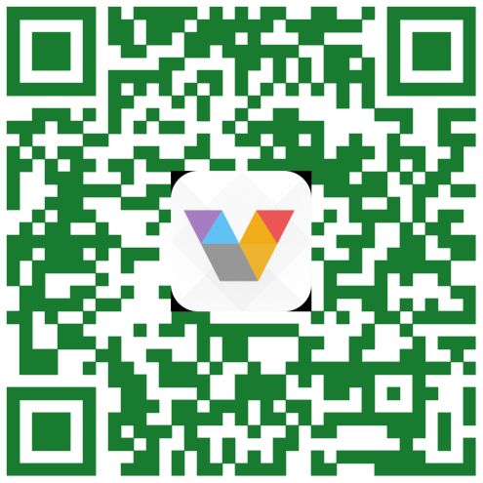
After installation, enter the login interface. For the first login, you need to register a personal account. Click "Register Now" at the bottom of the page, enter the library public account and password, click login, enter the personal account registration interface, and follow the prompts to enter your personal mobile phone number and verification code to complete the login.
(Those who have already registered a personal account or a learning library account on a computer can log in directly using this account without the need to register again)
Public account of Southern University of Science and Technology Library: nfkjwkt, password: 123.

