Complete Anatomy
注册步骤Registration steps：
- 请在微软商店、苹果APP Store、Vivo商店、华为应用商店等搜索“Complete Anatomy”软件并下载安装（若部分品牌未提供应用商店，可先下载Vivo商店、华为应用商店等），支持Windows、iOS、OS、安卓、鸿蒙等系统，可在电脑（须Windows10及以上版本）、平台及手机上使用。
Please download the software “Complete Anatomy” from Apple Store, Windows Store, Vivo APP Store, Huawei APP Store, etc. “Complete Anatomy” supports Windows, iOS, OS, Android, Harmony OS and can be used on computers (Windows10 and above version), tablets and mobile phones. You may refer to the links below for downloading.
- Apple store: https://apps.apple.com/cn/app/id1309253074
- Windows store: https://www.microsoft.com/zh-cn/p/complete-anatomy-platform-2020/9nblggh40f2t?activetab=pivot:overviewtab
- Vivo：https://h5coml.vivo.com.cn/h5coml/appdetail_h5/browser_v2/index.html?appId=3398280&resource=301&source=7
2、一定确保“位置”和“用户”，分别选择为“中国”和“否” ，如下图。
注：如果错选，请删除卸载软件，重新安装，再次选择。
Please make sure to select the correct options from the drop-down menu as shown in the screenshot below.
3、创建账号- 使用学校邮箱进行注册。
Please use your institutional email address to register.
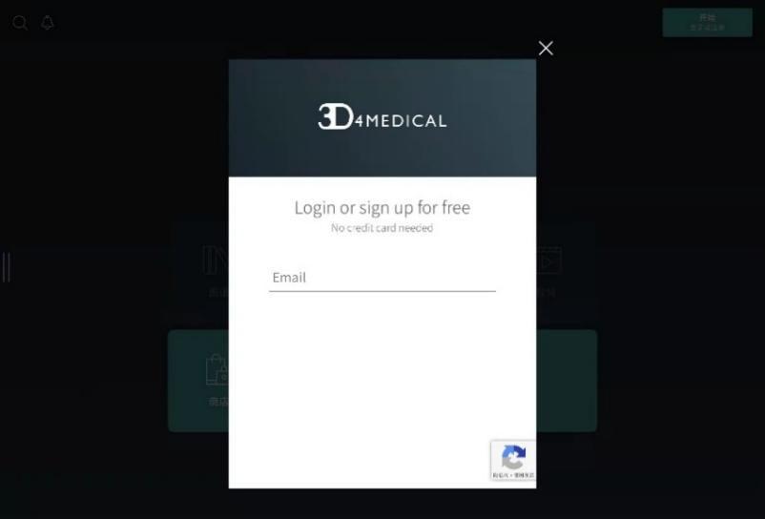
- 打开<设置>，<我的账户> 输入机构12位“激活码” （试用激活码：JCL1EN5V0U4Q）
Please go to “Settings” after login, find “My Account” and enter the activation code (Trial Code: JCL1EN5V0U4Q).

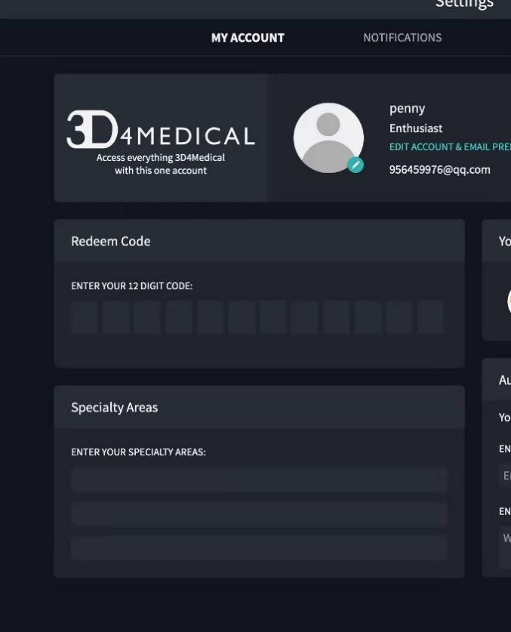
- 了解Complete Anatomy 的更多功能及使用技巧，请扫描下方二维码。
You may scan the QR code below to get more details on how to use “Complete Anatomy”.

