南方科技大学CAS SciFinder^{n}认证系统首次登录指南
2025年12月
第1步，点击链接https://sso.cas.org/sp/startSSO.ping?PartnerIdpId=https://idp.sustech.edu.cn/idp/shibboleth&TargetResource=https://scifinder-n.cas.org/，访问CAS SciFinder^{n}数据库统一认证链接，完成授权登录。
Step 1 – Click https://sso.cas.org/sp/startSSO.ping?PartnerIdpId=https://idp.sustech.edu.cn/idp/shibboleth&TargetResource=https://scifinder-n.cas.org/and login to the school platform.
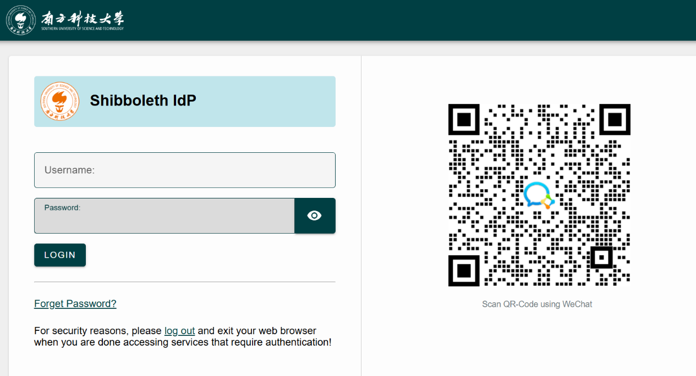
第2步- 在弹出窗口中，填写本人南方科技大学域名邮箱并通过验证码完成验证。输入非学校域名邮箱将导致账号无法正常使用。
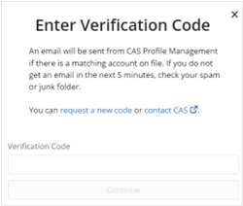
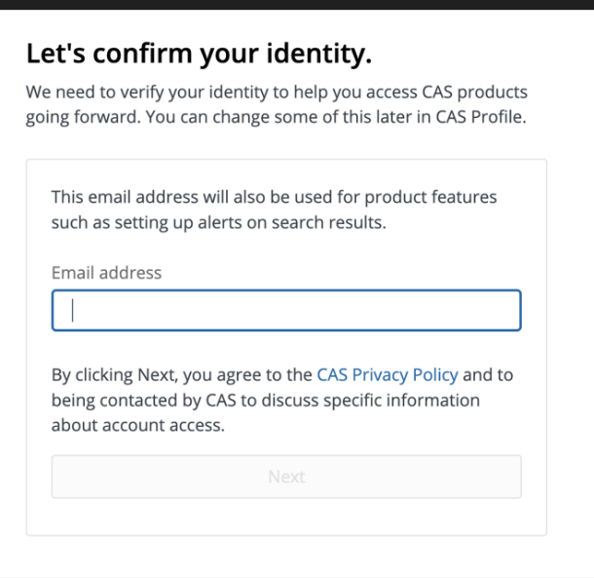
Step 2：In pop-up window, input and verify your Southern University of Science and Technology school domain email by entering the verification code. Non-campus domain email will lead to access issues.
第3a步，如是新用户，输入个人用户信息示，示例如下。
Step 3a –For new users please enter and/or verify information, see example below.
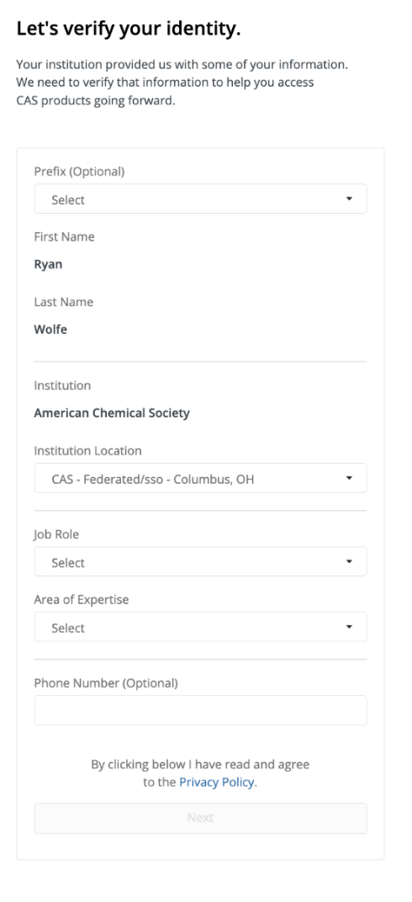

第3b步， 如已有CAS SciFinder^{n}账号，系统将自动根据邮箱匹配原CAS SciFinder^{n}账号。
Step 3b – For existing users that match existing email (or CAS ID) click to link access with current account.
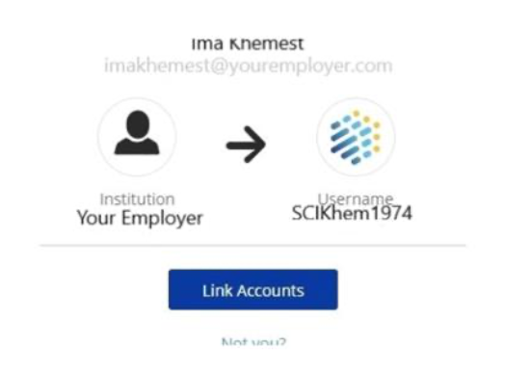

备注：一旦用户通过CARSI 关联已有CAS SciFinder^{n}账号，将无法再通过CAS SciFinder^{n}账号和密码登陆。原CAS SciFinder^{n}账号和密码登陆将失效。
Note: Once the user has accessed their account via the federated connection, they will no longer be permitted to access via CAS SciFinder^{n} ID and password. The CAS SciFinder^{n} ID and password will be invalid.

