Access Medicine数据库个人账号创建步骤
- 需要在学校IP范围内访问Access Medicine数据库，网址如下：
https://accessmedicine.mhmedical.com/ ，登陆后右上角会显示
Access Provided by: Southern University of Science and Technology，如下图：
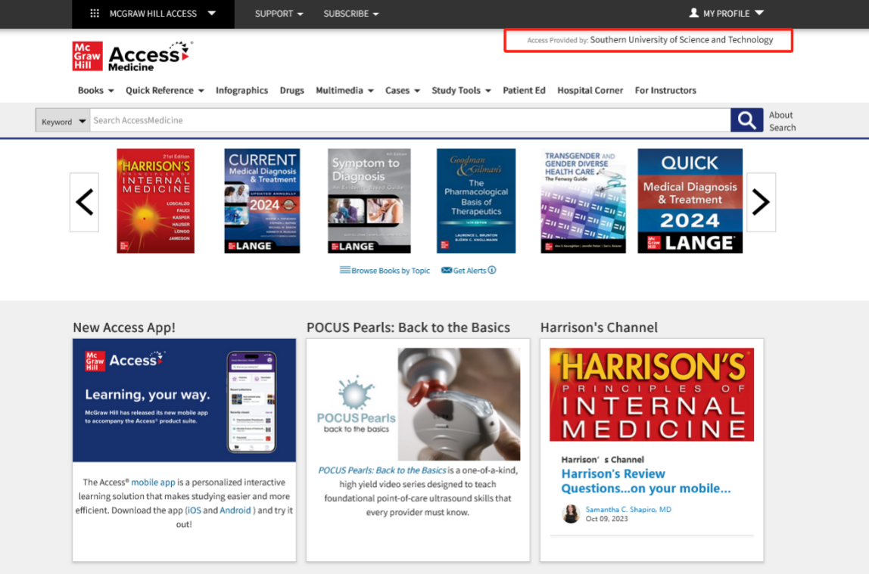
- 在步骤一的前提下，点击右上角My Profile，选择Sign in or Create a Free Access Profile。
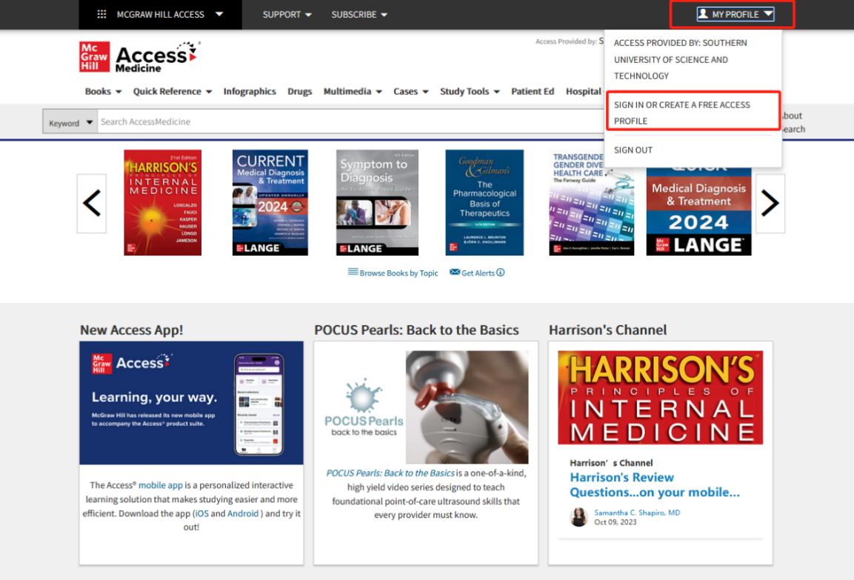
- 在弹出的对话框中，选择Create a Free Access Profile.
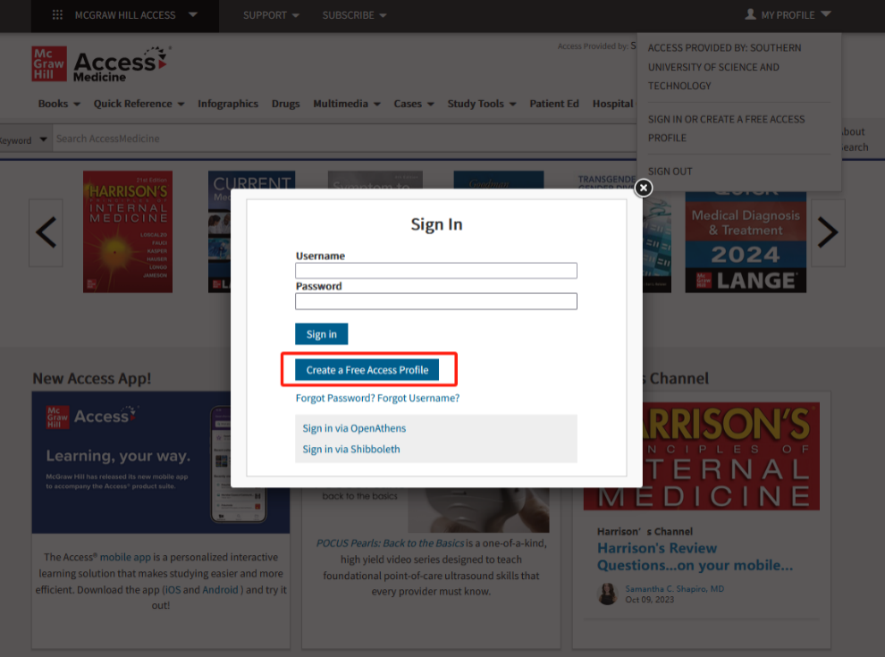
- 在接下来弹出的对话框中填入个人信息，例如邮箱，密码等带星号信息后，点击Create Profile即可。
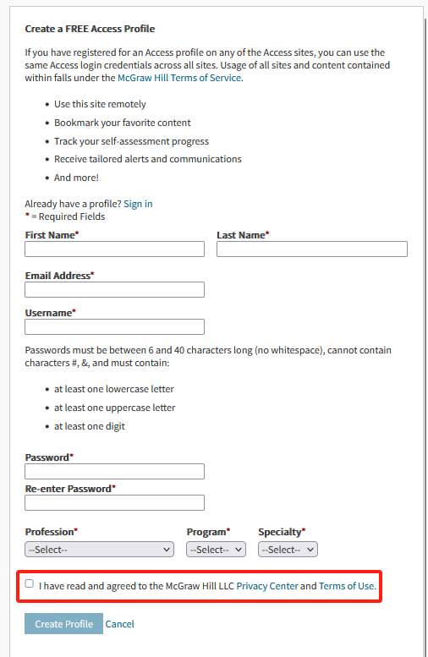
- 创建成功后，在Sign In处输入设置好的账号和密码即可在90内远程访问数据库，不受IP的限制。只要该账号在校园IP范围内登陆过，即可刷新90天的远程访问时间。
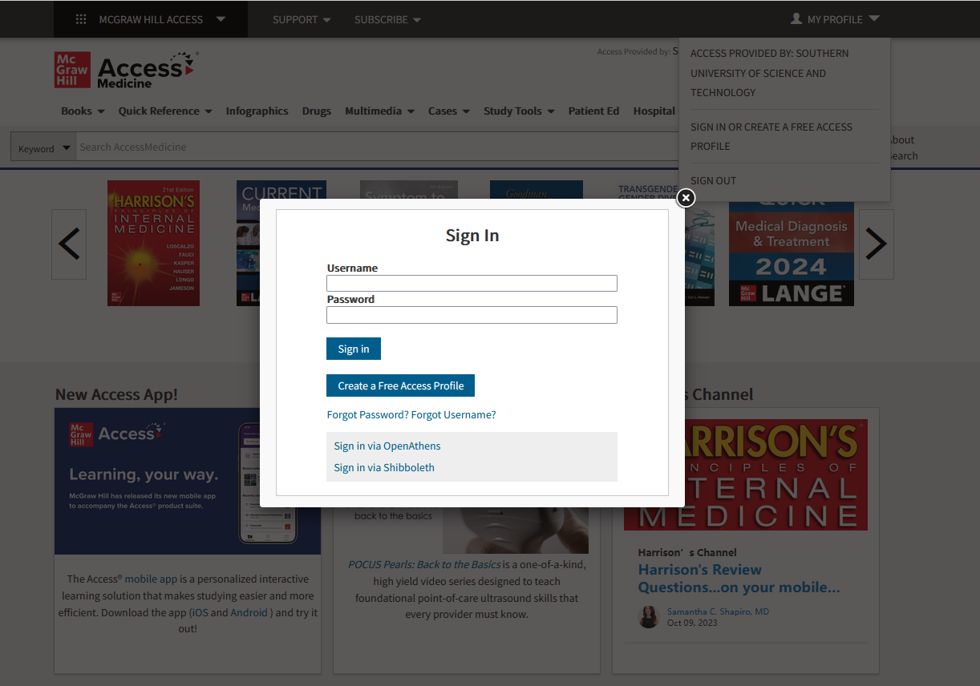

Access Medicine: Steps to create MyAccess Profile
Step 1. Access Access Medicine within the school's IP range by visiting the following website: https://accessmedicine.mhmedical.com/ . After logging in, you will see 'Access Provided by: Southern University of Science and Technology' in the top right corner, as shown in the image below：
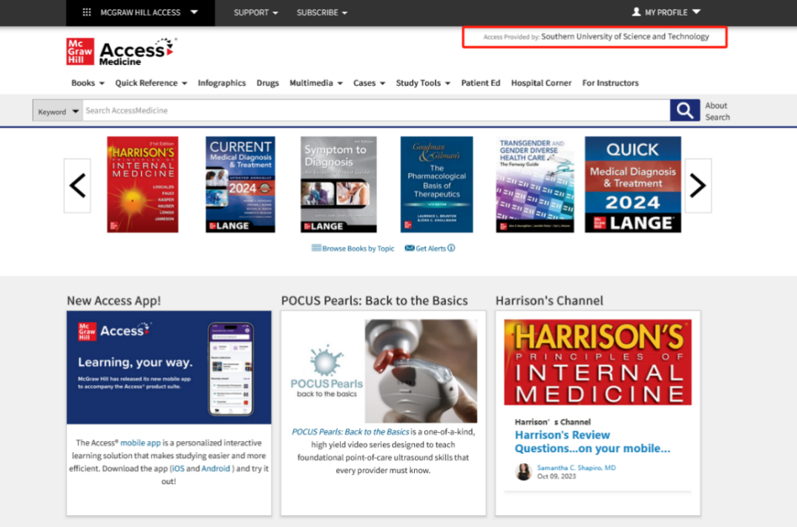
Step 2. Then click on "My Profile" in the top right corner and select "Sign in or Create a Free Access Profile".
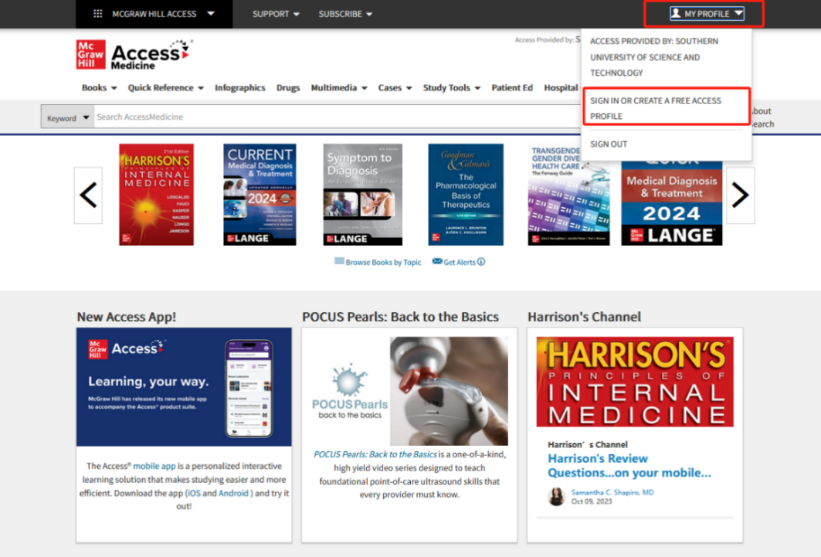
Step 3. In the popped-up dialog box, choose ‘Create a Free Access Profile’.
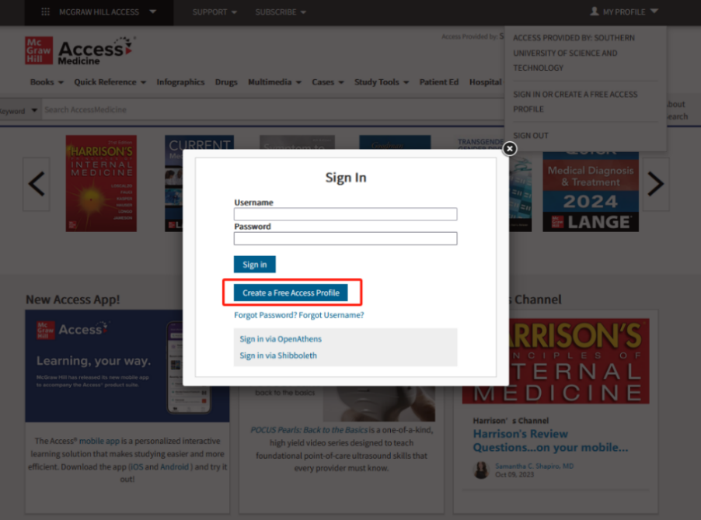
Step 4. In the following dialog box, enter your personal details, including your email address, password, and any other details marked with an asterisk (*). Then click on ‘Create Profile’ to complete the process.
Step 5. After successful creation, enter the designated username and password in the 'Sign In' section. This will allow unrestricted remote access to the database for 90 days. As long as the account is logged in within the campus IP range, the 90-day remote access period can be renewed.

