Registration steps (注册步骤)：
1. Visit the links below and click on “Get Started”.
访问上述链接后的界面，点击“Get Started”。
For Student: https://www.osmosis.org/cohort-invite?id=3207&k=52S1VgdhQaSwce9U6dXmSffpQ0ma38mH
For Faculty:
https://www.osmosis.org/cohort-invite?id=3208&k=y8yhQA7eQ5GAW9UfmGoZOt1KSUmQpvBm
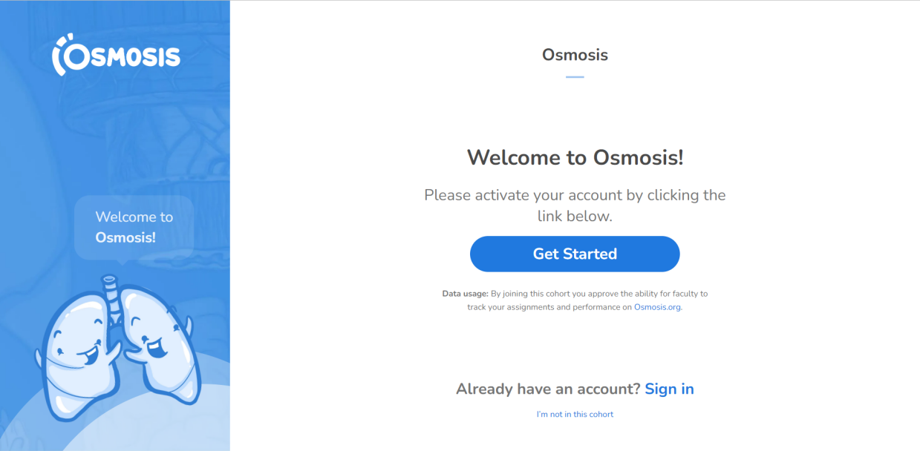
2. Please sign in if you have an account already. Otherwise, please click on “Sign up” for registration.
登陆个人账号，如尚未注册请点击 “Sign Up”。
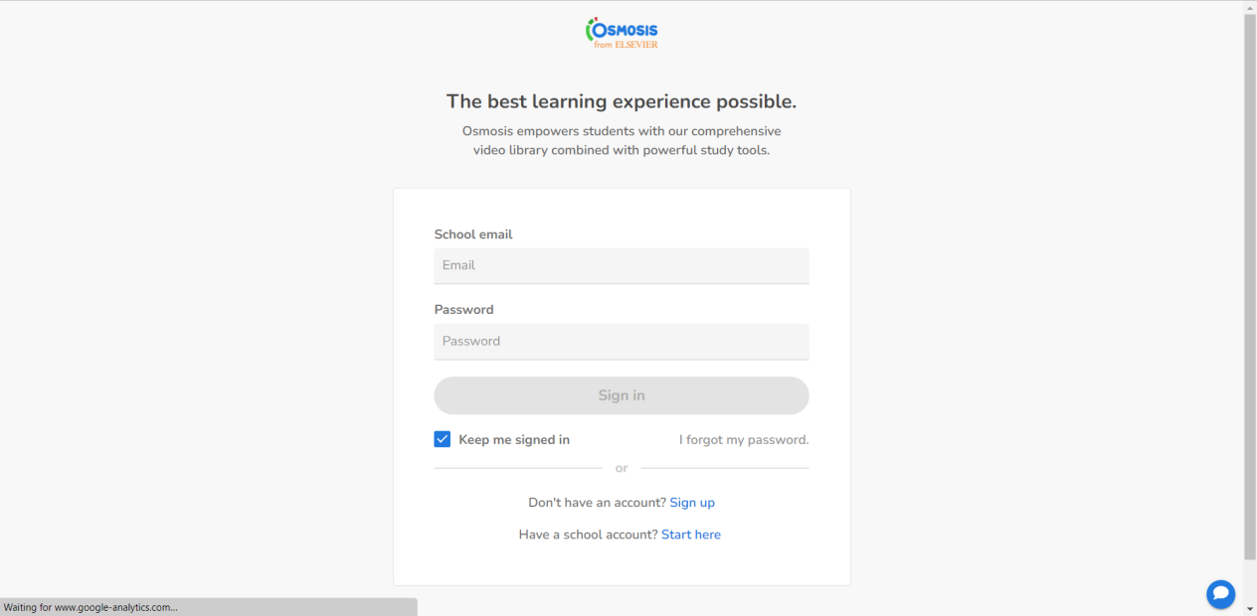

3. Once registration is completed, you can enjoy Osmosis now by accessing “Go to Dashboard”.
注册完成后，再次登陆后选择 “Go to Dashboard” ，可进入个人学习看板，浏览全部学习视频、建立个人学习卡、建立笔记等，进行完整内容的试用体验。
