线上书展荐购操作指南
How to recommend?

目录
Content

1. 登录 Login 2
2. 选择学科 Choose The Subject 3
3. 填写个人信息 Fill In Personal Information 5
4. 生成个人账户 Create Personal Account 6
5. 填写荐购理由 Fill In Reasons For Recommendation 7
6. 提交推荐 Submit Your Recommendation 7
7. 取消荐购 Cancel Your Recommendation 8

2022 Online Book Fair: https://www.cnpbook.com/fascicle/0786e05b1f04427ea38f7cb4686cb874

登录 Login
打开书展网站，通过“账号密码登录”，登录图书馆机构账户（账户名：SUST001，密码：520lib）。
Login to the Library’s institutional account on the Book Fair website (user name: SUST001, password: 520lib).
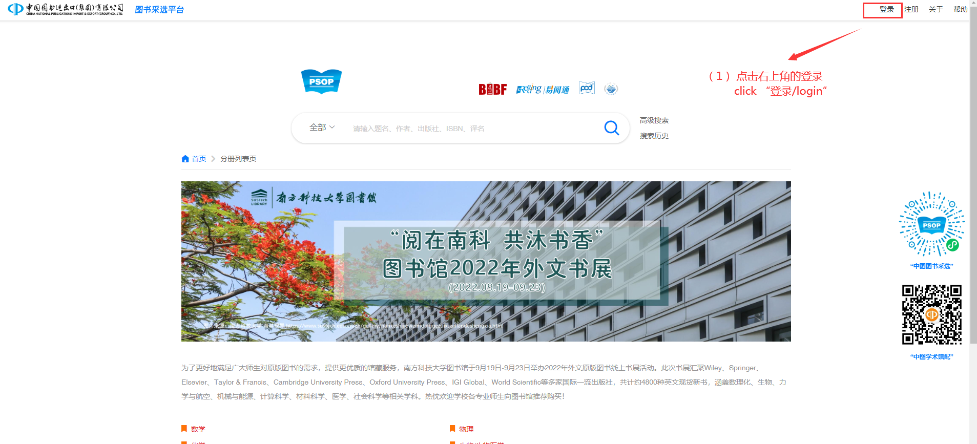
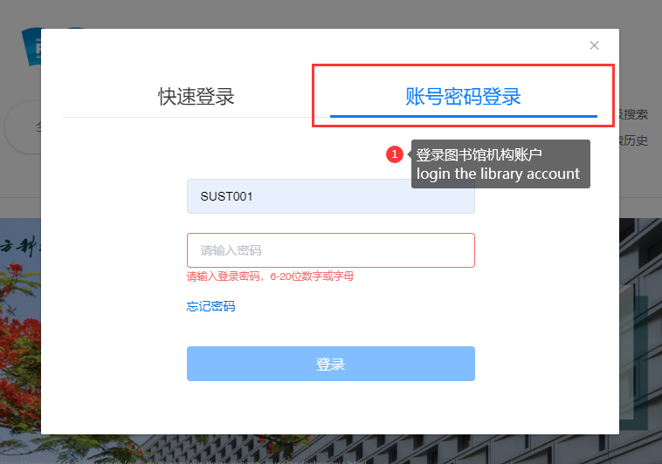

选择学科 Choose The Subject
选择你感兴趣的学科，挑选您想荐购的图书，可以同时勾选多本图书，点击“推荐”。
All the books are classified by subjects. Choose the subject you are interested in, tick the books you would like to recommend, and click “recommend(推荐)”.

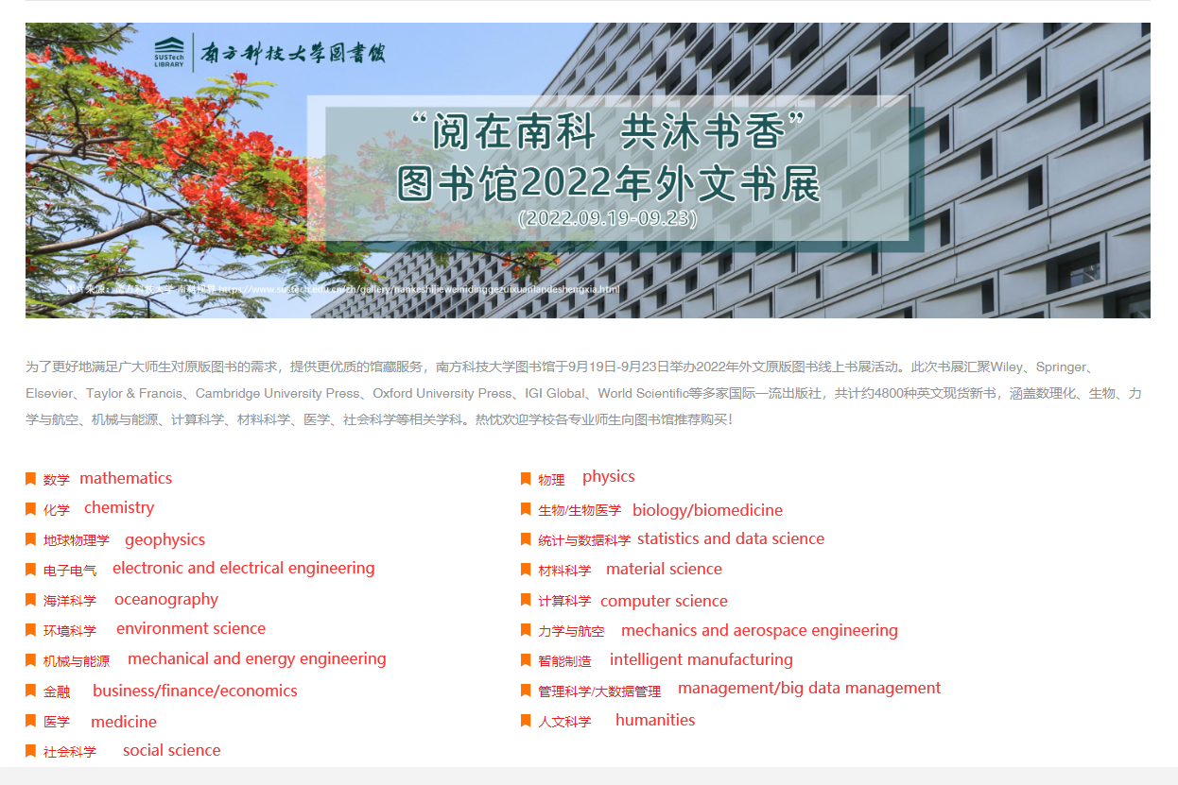
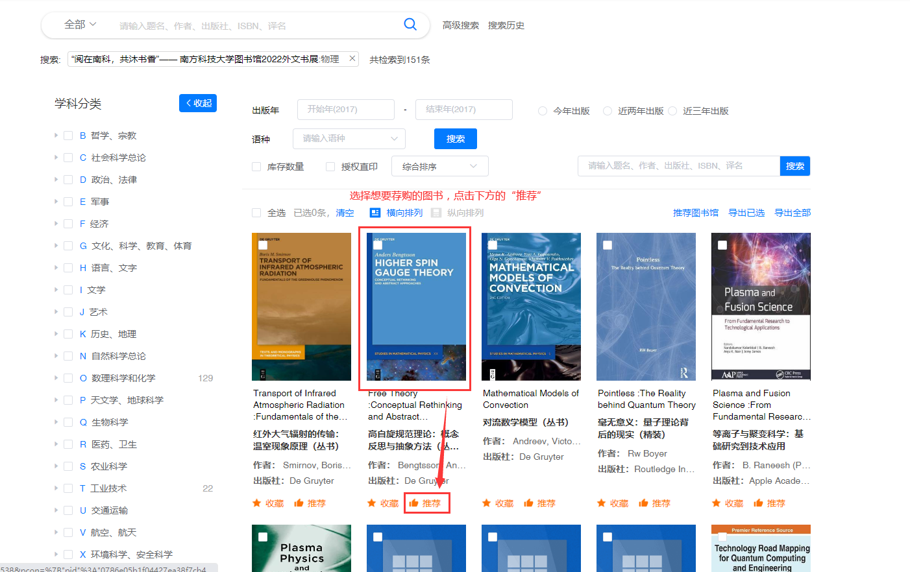

填写个人信息 Fill In Personal Information
填写推荐人信息，请如实填写，以便馆员核实身份以及后续图书上架通知。
Fill in information like name, campus ID number, college/department and email address, which is required for confirmation by the librarians and subsequent notification when the books are available.
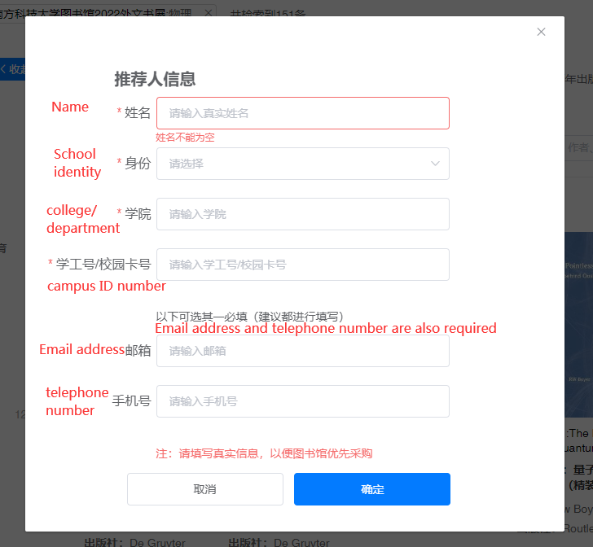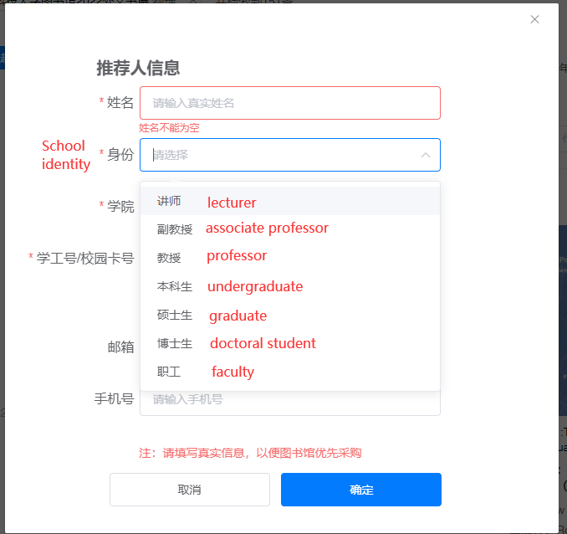

生成个人账户 Create Personal Account
个人信息填写完毕后，系统会根据用户填写的邮箱/手机信息创建个人账户，账户名为用户填写的邮箱/手机号，初始密码均为123456。生成个人账户后，后续荐购可以使用个人账户荐购，无需每次填写信息。
A personal account will be created once the user has filled in his/her email address or telephone number.
User name: the email address or telephone number that the user has filled in
Initial password: 123456

填写荐购理由 Fill In Reasons For Recommendation
填写荐购理由（选填），点击“推荐”。
You can leave notes for your recommendation (optional). Click the blue button “recommend(推荐)” to submit the recommendation.
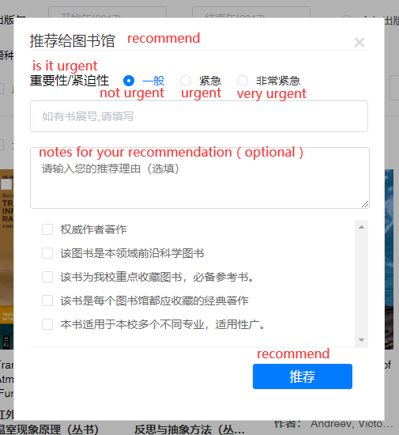

提交推荐 Submit Your Recommendation
以上操作完成后，顶部会显示“荐购成功”。
The little green sign shown on the page means your recommendation has been submitted.
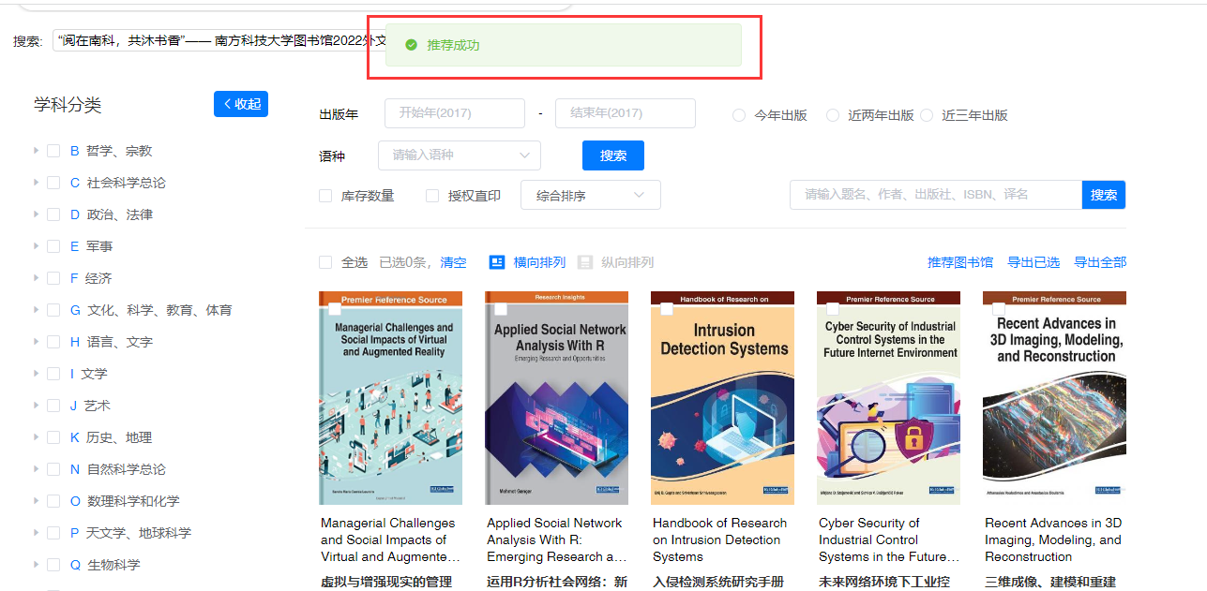

取消荐购 Cancel Your Recommendation
荐购成功的图书下方荐购按钮会变成“取消荐购”点击即可直接取消荐购
To cancel your recommendation, you should click the grey button “cancel(取消荐购)“ under the book title.
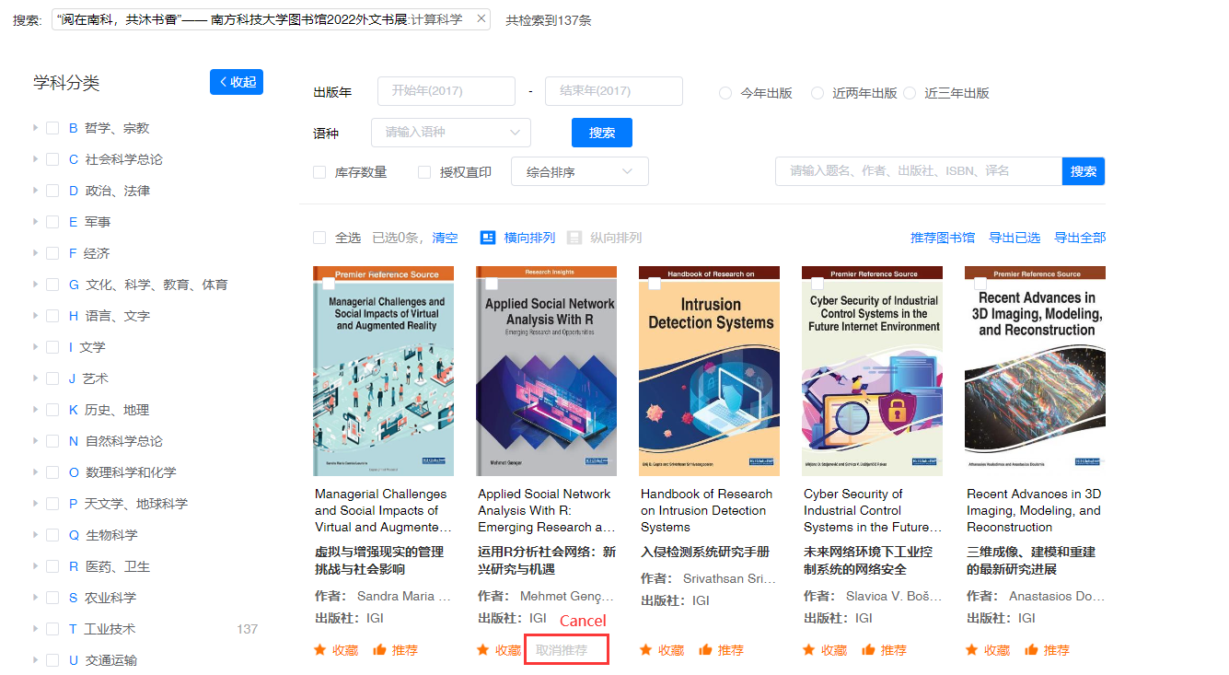
或者点击右上角的“我的推荐”，可以见到荐购的所有图书，点击“取消推荐”即可取消荐购。
Or, (a) Click “my recommendation(我的推荐)” on the page’s top right corner.
(b) You may see all the books that you have recommended. Find the books you’d like to cancel, and click “cancel(取消推荐)”.
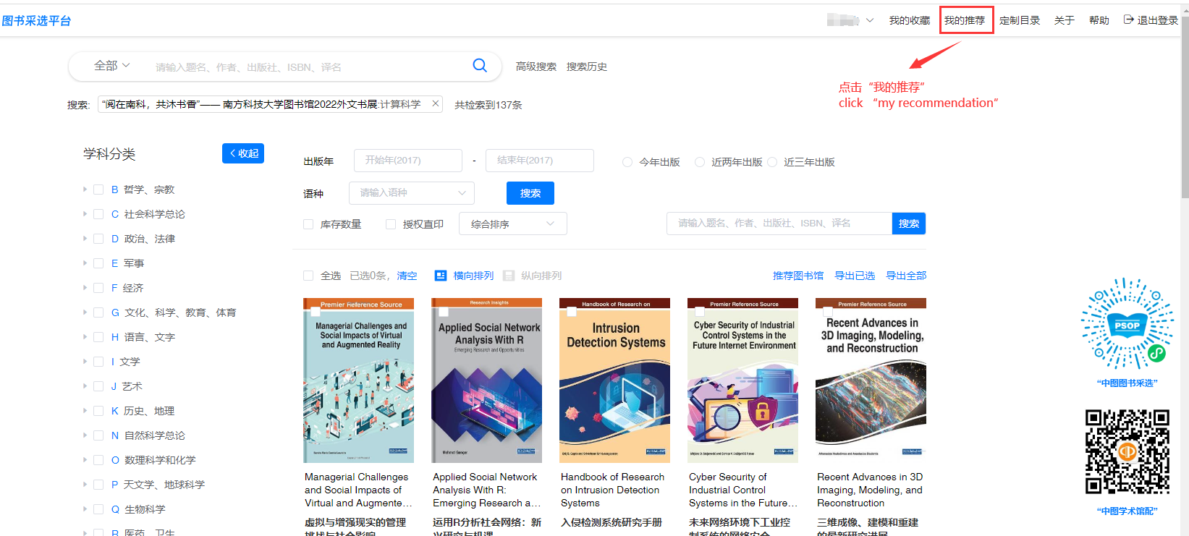
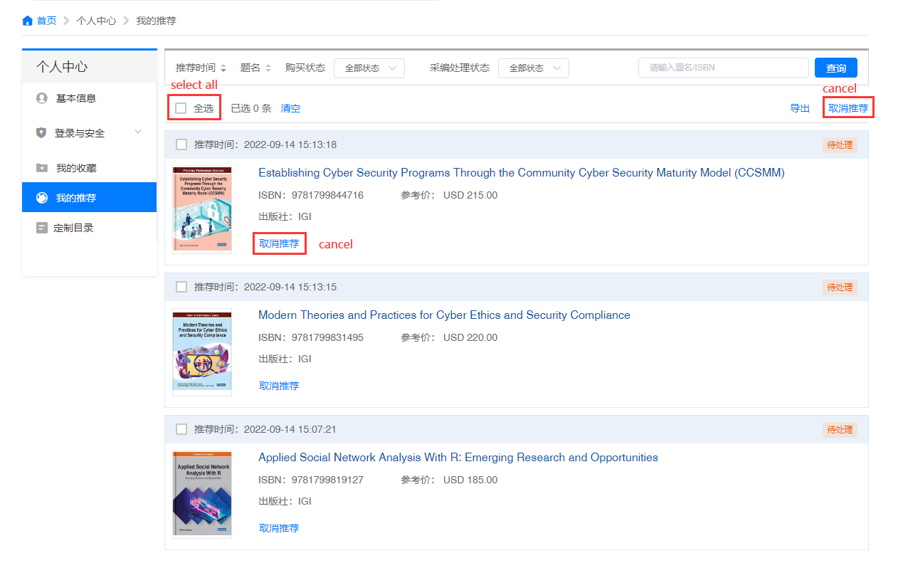

如需咨询，请联系：wanglx2021@mail.sustech.edu.cn，0755-88010830。
For enquirers, please contact: wanglx2021@mail.sustech.edu.cn, 0755-88010830.

