New Oriental interactive oral English use brief introduction
1. New Oriental online interactive oral English platform content brief introduction
New Oriental Online interactive oral English platform (oral.koolearn.com) is a student-centered, comprehensive coverage of New Oriental Education Group, a combination of professional English recognition technology team, and a student-centered, comprehensive, practical and intelligent interactive oral English product.
New Oriental online interactive oral platform provides a complete set of oral learning solutions, from learning, testing, practice, with four links to gradually improve spoken English. Interactive oral platform including basic oral English, advanced oral English, application, cool speaking, test oral five course classification, practical training also covers the ielts oral, business English, professional four test, oral, literature reading, professional eight test, tourism English, university four, toefl test, oral life, university six levels of oral courses, users can according to their own needs to add to the workrange, in addition, and American pronunciation and English pronunciation practice course, perfect match the users of all kinds of needs.
2. New Oriental interactive oral English platform characteristics
1. Multi-dimensional detection and sound evaluation
Leading speech recognition technology, from the pronunciation, fluency, accuracy, integrity, intonation, volume, speed and other multidimensional analysis of your oral English level, provide one-to-one curve feedback and score feedback, but also statistical analysis to generate personalized reports;
- 360 degrees of no dead-end training
For different scenarios, the interactive oral English platform provides a large number of oral English output training materials and reasonable error correction learning mode, which accurately strengthens the oral English level of learners in different scenarios from multiple perspectives.
3. "Hi together"
Every month, a number of online video real-time interactive live class, to give users the most real oral use environment, with foreign teachers and New Oriental teachers online oral interaction, answer questions, discussion, recitation, imitation, speech, debate.
4. Science and technology era, intelligent interaction
The New Oriental oral English platform adopts the leading speech recognition technology to fully optimize the online learning experience, and the perfect combination of advanced technology and high-quality content greatly promotes the improvement of oral English learning efficiency.
3. New Oriental interactive oral platform use instructions introduction
Computer side: oral.koolearn.com, direct access within IP, can register a personal account, with the account can be accessed outside the IP.
Mobile terminal: installation and use process: scan the code to download registration and login subscription courses
1. Scan the code, open the link, jump to the page on the right, select the version according to the prompts, download and install it.

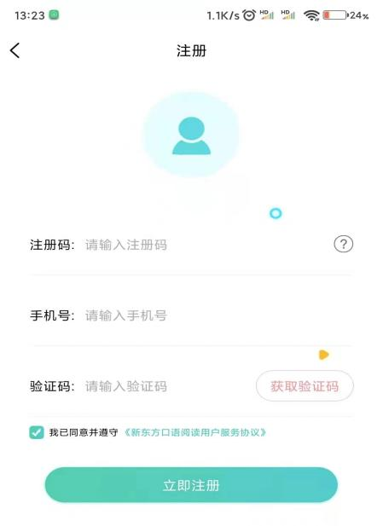
2. After the installation, enter the login page,
Please click "Register",
Enter the registration of: nfkjdxtskypt1
Fill in the personal mobile phone number,
obtain the verification code, and then complete
the registration.
(If the IOS system cannot open the app after downloading, please see the introduction on the end page first)

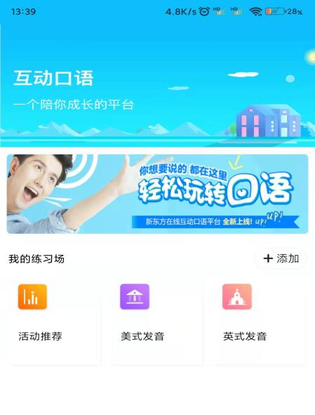
- After successful registration, jump, enter
the home page, you can start the wonderful
journey of interactive oral learning.

IOS system exception handling
The IOS system cannot open it after downloading the app. "Untrusted enterprise developers" appears. Please follow the following steps.
- Open the Universal section in Settings;
2. Find out the "VPN and Equipment Management" and click on this column;
3. Then find the "interactive spoken English" app, click to select the trust, and then return to the interface to open our app.
