New Oriental online micro class trial brief introduction
(Southern University of Science and Technology)

1. New Oriental online micro class content brief introduction
New Oriental Online micro-classroom learning platform (vl.koolearn.com) is a learning platform product with video as the core resource developed by New Oriental Online on the trend of micro learning and micro courses. It is positioned as a language application encyclopedia based on application scenarios. The micro-classroom curriculum system includes resources such as oral English learning, business learning, foreign language learning, language examination, study abroad through train, workplace practice and so on.
Based on the concept of borderless and customized design, micro-classroom not only supports the integrated applications of PC, APP, WAP and interactive large screen, but also supports users to collect, download and combine knowledge points to realize customized learning. Each video is an independent knowledge point, each knowledge point is about 10 minutes; the video volume is small, good picture quality, faster and smoother playback; learners can use the fragmented time to learn anytime and anywhere, enjoy in the ocean of knowledge.
1. Characteristics of micro-classroom learning
A. The first feature of micro-video learning is "micro", which realizes "short-term learning" and "fast learning" through the micro-of materials
B. To meet the independent needs of students, students according to their own situation to choose the learning content, strong flexibility
C. Learning efficiency is improved, due to students' independent choice, students have strong willingness to learn, high enthusiasm, and effectively avoid repetitive learning;
2. The characteristics of the micro-class content
A."Short": Each video is an independent knowledge point, no more than 10 minutes
B."Small": independent knowledge points, learning more targeted, and learning more fluent
C."Fine": choose New Oriental online education field for many years of rich teaching and research experience, famous and excellent teacher resources, select knowledge points
3. Learning style of micro-classroom
A. Fragmentation learning
The course is composed of independent knowledge points "micro video", learning an independent knowledge, less than ten minutes, easy to master, improve the flexibility of learning time, at the same time can be targeted according to their own situation to learn repeatedly, improve the learning efficiency.
B. Retrieval learning
You can quickly supplement the missing knowledge by searching the course and watching only specific knowledge point videos.

2. New Oriental micro classroom use instructions introduction
Computer side: vl.koolearn.com, direct access within IP, can register personal account, account can be accessed outside the IP.
Mobile terminal browser access: wkt.koolearn.com
Mobile APP access: installation and use process: scan code download registration and login subscription courses
1. Scan the code, open the link, jump to the page on the right, select the version according to the prompts, download and install it.
(You can also apply market search: New Oriental Micro classroom)

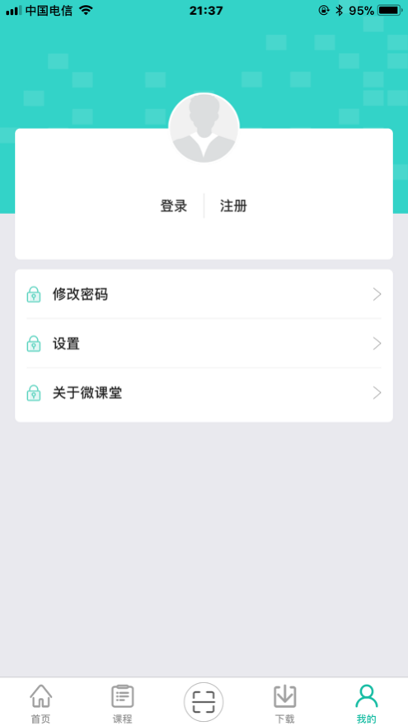
- After the installation, enter the home
page, click "My" in the lower right corner, and
register your account first, please click
"register" in the middle of the page.
(Note: If the iOS system cannot open the app
after downloading, please look at the introduction
of article 6 of the end page to open it.)

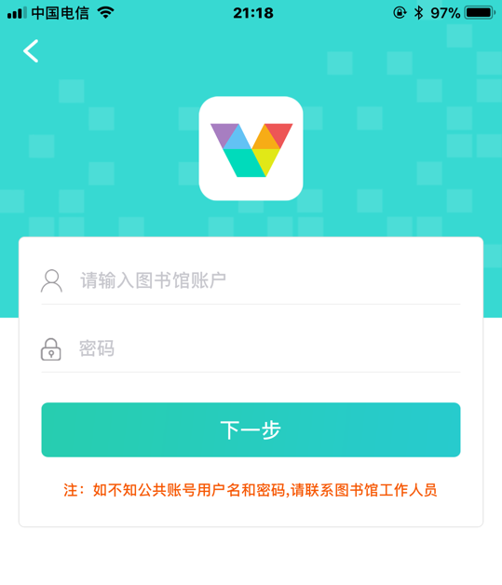
3. After clicking register, enter the library account authentication page on the right. Please enter the library
Account number: nfkjwkt
Password: 123
Then click "Next".

4. Jump to the registered personal account page, enter the user name, mobile phone number and password you want to register, and then click Next.
★ Due to the large number of users, the user name will occasionally repeat the cases, to avoid such cases, please give yourself a personal name. If "this mobile phone number has been registered", it means your mobile phone number has been registered as a user of "New Oriental Online". Please register with a new mobile phone number to retrieve your password.
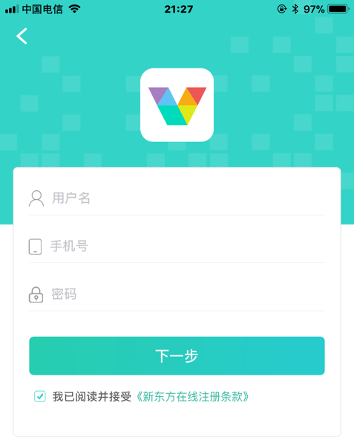

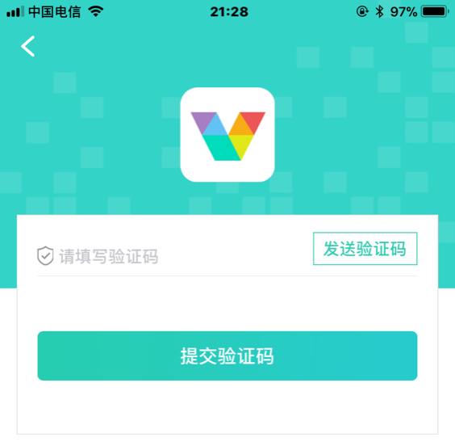
5. Jump to the verification page, click Send verification code, fill in the verification code, click Submit, and you can complete the registration of personal account.

6. After successful registration, jump, enter the home page, you can start the wonderful journey of micro-class learning.
