New Oriental handheld learning platform trial introduction

(Southern University of Science and Technology)

1. New Oriental online handheld learning platform brief introduction
New Oriental Palm learning platform (referred to as "New Oriental Palm Learning") is a professional mobile learning platform tailored by New Oriental Online for various universities and libraries."New Oriental Palm Learning" takes providing systematic, personalized and accurate mobile learning courses, with library information service functions to meet the needs of users for mobile learning, interesting learning and fragmented learning.
New Oriental palm contains six modules: bilingual reading, interest, listen to, video courses, reading training, audio courses, handheld question bank, etc., content involves: subject reading, 4, one's deceased father grind, overseas exam courses, college English grammar, business English, overseas survival English, vocabulary, oral, oral, listening, classic prose, British and American culture, film appreciation, American life, American English, campus English, American school graduation speech, fairy tale fable, etc. It can achieve many aspects of English improvement and leisure learning, such as examination-taking, oral English improvement, English and American culture learning, leisure reading and listening, and so on.
College access logic, through the school public account level control, through the school public account after the certification can register a personal account. It is not limited by network scope, no IP restrictions, no concurrency restrictions, and fully meet the learning and use needs of teachers and students.
Platform resources download shows that all the resources on the platform can be downloaded to the APP through the wireless network, and then the resources downloaded to the APP can be accessed at any time in the absence of the network. The resources are only used in the APP and cannot be transferred out.

2. New Oriental palm characteristics and instructions introduction
- Mobile study, go with you for you:
Fragmented learning has become the most popular way of learning at present. "New Oriental Learning" takes 3 minutes a reading, 5 minutes an audio lesson, 7 minutes a video lesson...…The latest and most fashionable learning experience makes you easily seize the scattered time, always charge, and constantly improve.
- Characteristics of the curriculum system: fine, clever and complete
1. Select exam-oriented, application, basic and promotion courses to meet the mobile learning needs of different groups of people.
2. It covers video, audio, text, and interactive practice courses. The courses are lively and interesting, and have rich display forms.
3, listening, speaking, reading, writing, translation, the course content is complete, the application of skills to catch all.
- Personalized mobile learning experience:
"New Oriental School" provides "my wrong questions", "my collection", "my download", "learning record" function services, to realize the service tenet of "one person, one class" and meet the personalized mobile learning experience.

More exciting functions, quality courses, waiting for you to find out!
Installation and use process: scan the code to download, register, login and subscribe to the courses

One, scan the code to download

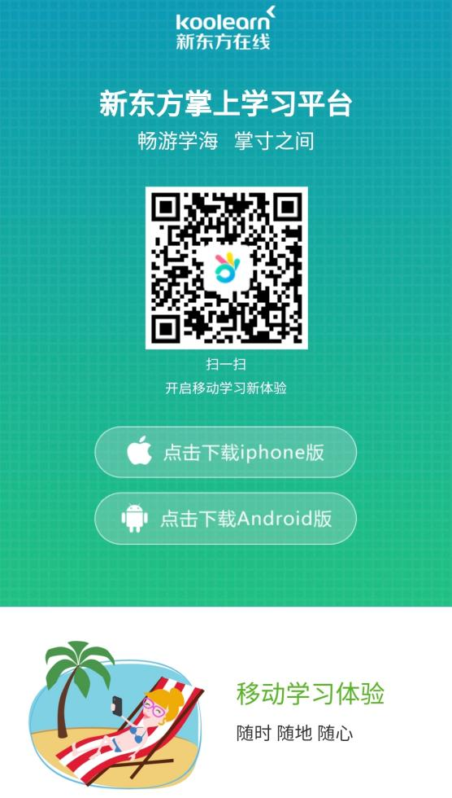
Scan the code, open the link, jump to the page on the right, select the installed version and download it.

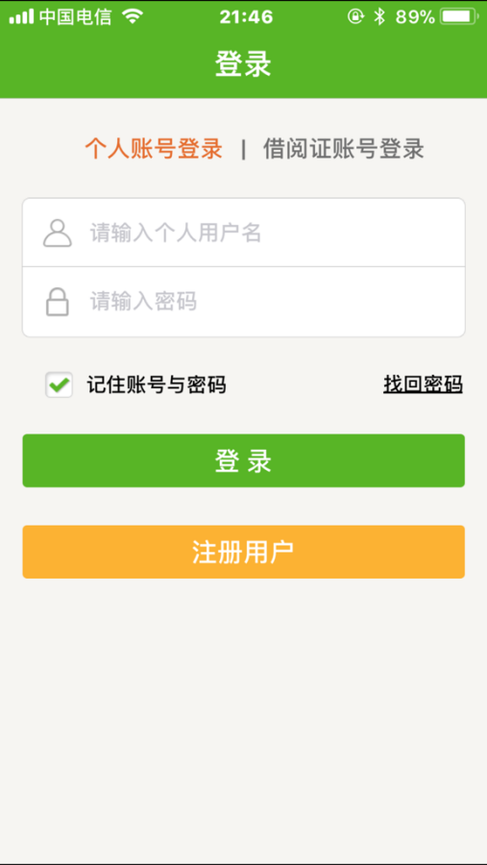
Two. registration and Login
- After the installation is completed, enter the
login page, as shown in the figure on the right.
For the first login, you need to register your
account before you can use it. Please click on
"Registered User" at the bottom of the page.
★ According to the requirements of the school, you can
also directly bind the student number or work number of
all the teachers and students, so that there is no need to
register the link, students can directly log in through the
student number to access the course.

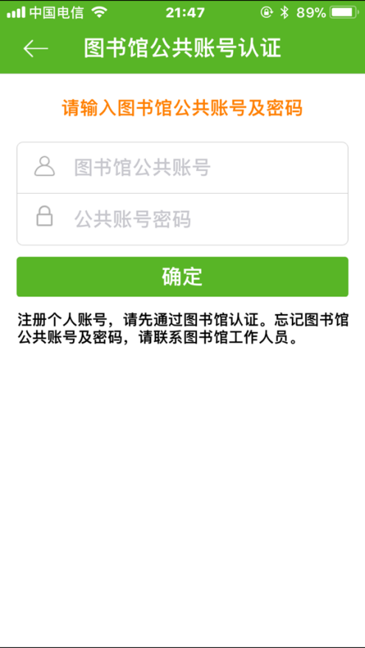
- After clicking register, enter the public
account authentication page on the right. Please
enter the library.
Public account number: nfkjdxtszsxxpt1
Account password: 123,
and then click OK.

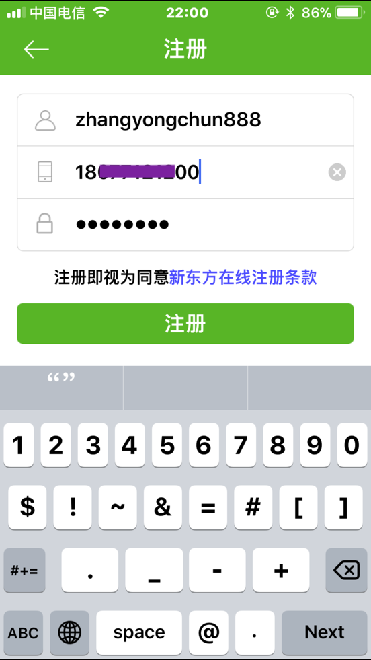
- Then enter the page of registering
your personal account, enter the user
name, mobile phone number and password
that you want to register, and then
click register.
★ Due to the large number of users, the user name
will occasionally repeat the cases, to avoid such
cases, please give yourself a personal name. If "this
mobile phone number has been registered", it
means your mobile phone number has been
registered as a user of "New Oriental Online".
Please change your cell phone number to retrieve
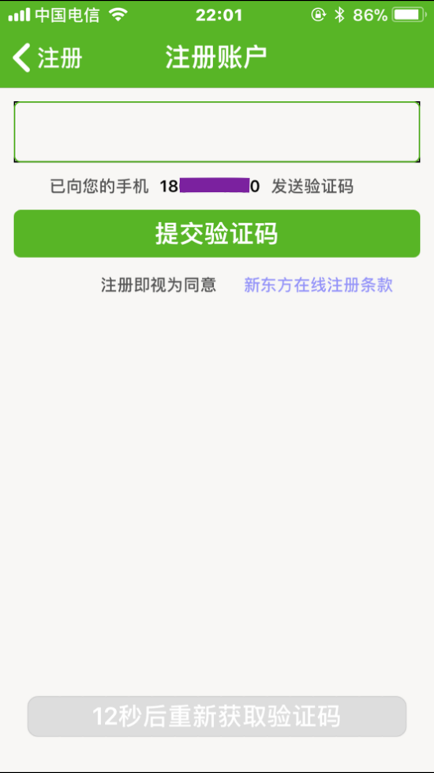
your password.

- After clicking the registration, use the
mobile phone number to receive the
verification code and submit the verification,
and complete the registration.

5. Register successfully, enter the home page, and start the mobile learning journey.
★ In the future, you can use your personal account and password to log in, and select "Remember the account and password". Next time you enter the App, you have no need to enter the user name and password, and then log in automatically.
